[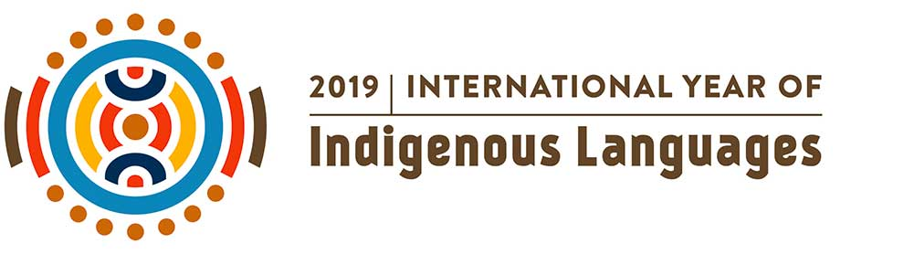](https://en.iyil2019.org/)

Lesson Activity: Create a ‘chatterbox’

Aim: To raise awareness of Indigenous languages

Specifically the Ainu (Indigenous people of Japan) and Australian Aborigines

* Discussion points: What is the official language in our country? Are there other languages spoken in our country? Are there indigenous languages spoken in our country?
* Show images of Ainu and Australian aboriginals (see below)
* Practice writing the word ‘Mum’ in English, Japanese, Ainu and Baradha (taking care with stroke order – see below)
* Make your own ‘Chatterbox” – see instruction sheets

RESOURCES

* Chatterbox template, instructions, sample and fold instructions
* [Ainu Images](https://www.bing.com/videos/search?q=images+ainu&src=IE-SearchBox&ru=%2fsearch%3fq%3dimages%2bainu%26src%3dIE-SearchBox%26FORM%3dIESR3N&view=detail&mmscn=vwrc&mid=CDDF6A3B1EEE8304F05DCDDF6A3B1EEE8304F05D&FORM=WRVORC)

[Aborigine and Ainu images](https://qedu-my.sharepoint.com/personal/mcorf5_eq_edu_au/Documents/Tallebudgera%20SS/LOTE%20Advocacy/YearofIndigenousLanguages/ABORIGINEAINUPICS.docx)

* [Words for Mother](https://qedu-my.sharepoint.com/personal/mcorf5_eq_edu_au/Documents/Tallebudgera%20SS/LOTE%20Advocacy/YearofIndigenousLanguages/Words%20for%20Mother.docx) -Looking at languages – English, Japanese, Ainu and the Baradha language (central Queensland Aboriginal language)

[State Library of Queensland Word of the Week](http://blogs.slq.qld.gov.au/ilq/2019/02/19/2019-international-year-of-indigenous-languages-word-of-the-week-week-eight/)

[Ainu Museum languages](http://www.ainu-museum.or.jp/en/study/eng14.html)

[Ainu Oral Literature](http://www.ainu-museum.or.jp/en/study/eng13.html)

[Aboriginal Languages](https://teachik.com/aboriginal-languages/) – further lesson ideas and information

Worksheet - Ainu, comparisons to the Australian Indigenous (Aboriginals)

(Document from JapaneseTeachingIdeasWeebly)

[](https://en.iyil2019.org/)

Instructions for ‘chatterbox’

* Prior to making the chatterbox, refer to discussion points and learn how to write the characters for haha, hapo and practice writing yanga (pronounced young-ah) and mum
* Cut either side of the chatterbox to ensure your chatterbox is square
* In each corner write one of the four words for mother
* Insert a mixture of the four words into the appropriate space within the sentences within the chatterbox
* For Japanese number practice, kanji could be included next to each number
* Fold the chatterbox using the fold instruction sheet
* Enjoy the chatterbox with your mother or friends



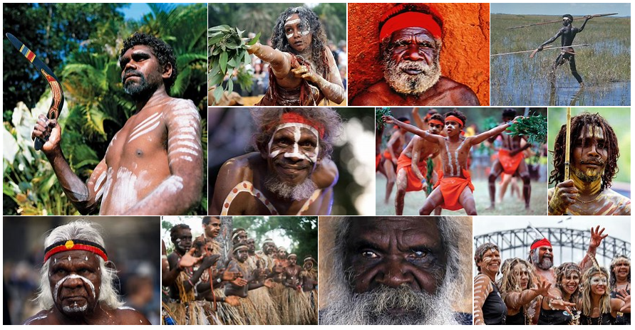



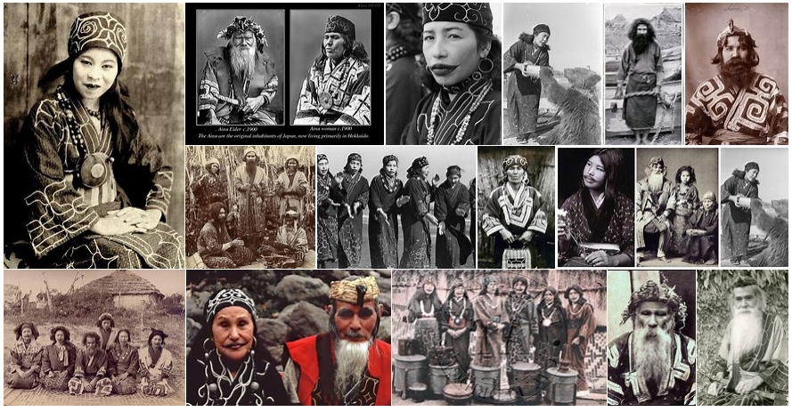

[](https://en.iyil2019.org/)

Words for ‘Mother’ in English, Baradha 　(Central Qld Australian Aboriginal), Japanese and Ainu

**



**



**

母 

**

ハポ

Sample - Chatterbox



Chatterbox





**The Ainu**

The Ainu are the original inhabitants of Japan. They are thought to have arrived possibly 14,000 years ago – 10,000 years before the ‘new Japanese’. It is not certain where the Ainu originated from, but it is thought that they have genetic links with the people of Tibet or early settlers of Siberia.

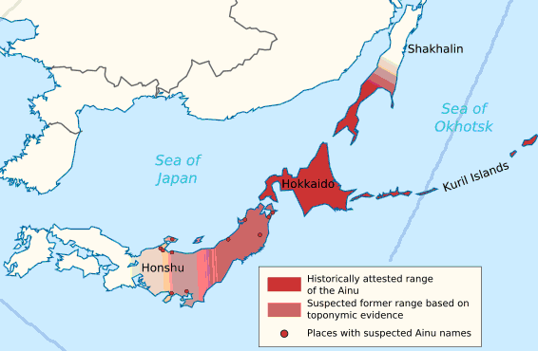The Ainu settled mostly in the northern tips of Honshu and Hokkaido. They were hunters, fishermen and gatherers living in harmony with nature. A village possessed a hunting ground of its own or several villages used a joint hunting territory. Their traditional food consisted of the flesh of bear, fox, badger, ox, or horse, as well as fish, fowl, millet, vegetables, and roots.

**Focus Questions**

1. Who were the Ainu?

2. How long ago are the thought to have settled in northern Japan?

3. What type of lifestyles did they lead?

4. What comparisons can you make to Indigenous Australians (be specific)?

**Religion**

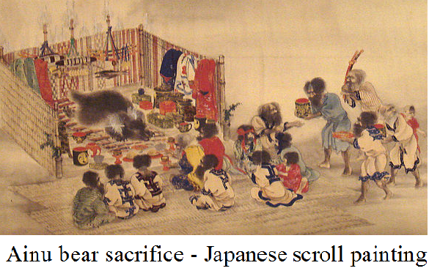

The Ainu are traditionally animists, believing that everything in nature has a *kamuy* (spirit or god) on the inside. The most important included Kamuy Fuchi, goddess of the hearth (fireplace in a house), Kim-un Kamuy, god of bears and mountains, and Repun Kamuy, god of the sea, fishing, and marine animals. The Ainu have no priests by profession; instead the village chief performs the religious ceremonies.

**Focus Questions**

5. Briefly describe the type of religion the Ainu practiced.

6. Do Indigenous Australians pray to gods like the Ainu? How would you describe the spiritual

beliefs of Indigenous Australians?

**Conflict and the Ainu Today**

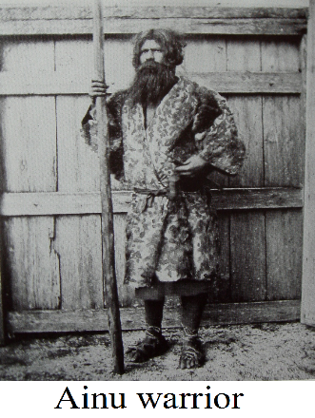The Ainu came into contact with ‘The Children of the Sun’ (ancestors of today’s ‘new Japanese’) 3,000 years ago. Despite fierce resistance, by the 9th Century CE the Ainu were eventually driven from their lands in Honshu. They found refuge in the northern island of Hokkaido. Hokkaido remained outside the control of the Japanese government until the late 19th Century.

In the late 19th Century, Hokkaido came under official jurisdiction of the Japanese government. Under the government policy of assimilation, the Ainu were prohibited from practicing their daily customs and were forced to follow Japanese daily customs. With an increasing number of Japanese colonising Hokkaido from Honshu, the oppression of the Ainu was replaced by discrimination against them. Discrimination against the Ainu still remains today and has become a major social problem.

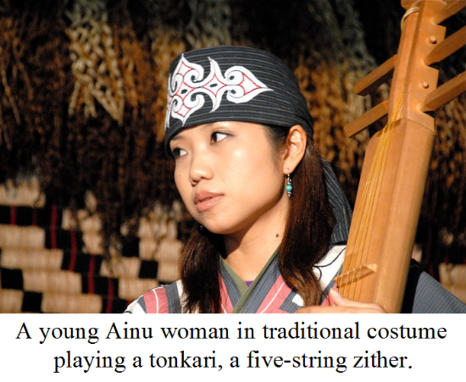

These days, various activities are being vigorously promoted to revive the Ainu language and to preserve and maintain Ainu culture, such as traditional dancing and various ceremonies. Ainu language classes are being held in various parts of Hokkaido.

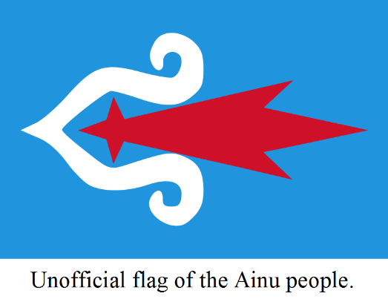Most of those who identify themselves as Ainu still live in this same region, though the exact number of living Ainu is unknown. This is due to confusion over mixed heritages and to ethnic issues in Japan resulting in those with Ainu backgrounds hiding their identities. Intermarriage with Japanese has blurred the concept of a pure Ainu ethnic group. Official estimates of the population are of around 25,000, while the unofficial number is upward of 200,000 people.

**Focus Questions**

7. When did Ainu contact with the ancestors of the ‘new Japanese’ begin? Do the experiences

of the Ainu, relate to early Indigenous Australian contact with Europeans (be specific)?

8. What similarities of ‘Assimilation’ are their between the Ainu and Indigenous Australians?

9. How is Ainu culture being promoted today?

10. Why is it hard to provide an exact figure of the Ainu? Are the same challenges faced in

Australia?